**A PROJECT REPORT**

**on**

**“****PowerBI and SQL Project ”**

**Submitted to**

**KIIT Deemed to be University**

**In Partial Fulfilment of the Requirement for the Award of**

**BACHELOR’S DEGREE IN**

**COMPUTER SCIENCE AND ENGINEERING**

**BY**

**SHUBHADEEP GHATAK**

**SAMYAK NATH**

21051343

21051333

**UNDER THE GUIDANCE OF**

**MR. DEEPENDRA SINGH SIR**



**SCHOOL OF COMPUTER ENGINEERING**

**KALINGA INSTITUTE OF INDUSTRIAL TECHNOLOGY**

**BHUBANESWAR, ODISHA - 751024**

**March 2024**

A PROJECT REPORT

on

“PowerBI and SQL Project”

Submitted to

KIIT Deemed to be University

In Partial Fulfilment of the Requirement for the Award of

BACHELOR’S DEGREE IN COMPUTER SCIENCE AND ENGINEERING

BY

UNDER THE GUIDANCE OF

Mr. Deependra Singh Sir



SCHOOL OF COMPUTER ENGINEERING

KALINGA INSTITUTE OF INDUSTRIAL TECHNOLOGY

BHUBANESWAR, ODISHA -751024

March 2024

KIIT Deemed to be University

School of Computer Engineering

Bhubaneswar, ODISHA 751024



CERTIFICATE

This is certify that the project entitled

“PowerBI and SQL Project “

submitted by

SHUBHADEEPP GHATAK 21051343

SAMYAK NATH 21051333

is a record of bonafide work carried out by them, in the partial fulfilment of the requirement for the award of Degree of Bachelor of Engineering (Computer Sci-ence & Engineering) at KIIT Deemed to be university, Bhubaneswar. This work is done during year 2023-2024, under our guidance.

Date:20 /3 /2024

Mr. Deependra Singh Sir

Project Guide

**Acknowledgements**

We are profoundly grateful to **Mr. Deependra Singh** of **Data Analytics** for his expert guidance and continuous encouragement throughout to see that this project rights its target since its commencement to its completion.

SHUBHADEEP GHATAK

SAMYAK NATH

**ABSTRACT**

This project report presents an in-depth exploration of Power BI integration with SQL Server for data visualization and analytics in the context of a Bachelor of Technology (B.Tech) Computer Science and Engineering (CSE) college project. The report highlights the significance of leveraging Power BI's capabilities to create interactive dashboards and reports by connecting seamlessly to SQL databases. It outlines the methodology employed, including data collection, preparation, modeling, integration with SQL Server, and dashboard creation using Power BI. The project aims to demonstrate the practical application of Power BI in extracting insights from SQL data sources, offering a valuable learning experience for CSE students interested in business intelligence and data analytics.

The report provides a detailed examination of the strategic utilization of Power BI's robust functionalities to construct dynamic dashboards and reports by establishing seamless connections with SQL databases. The methodology adopted encompasses various stages, including meticulous data collection, thorough data preparation procedures, intricate data modeling techniques, seamless integration with SQL Server infrastructure, and the proficient creation of visually appealing and interactive dashboards utilizing Power BI's intuitive interface. The project's core objective revolves around showcasing the pragmatic implementation of Power BI in extracting actionable insights from SQL-based data repositories, thereby offering a comprehensive and insightful learning experience tailored for CSE students with a keen interest in the realms of business intelligence and data analytics. We have also used SQL codes for analysing data.

**Keywords:** Power BI interactive dashboard, SQL connection, Key performance Indicator(KPI),



Contents

|  |  |  |  |  |
| --- | --- | --- | --- | --- |
| 1 | Introduction | | | 1 |
| 2 | Basic Concepts/ Literature Review | | | 2 |
|  | 2.1 | Introduction | | 2 |
|  | 2.2 | PowerBI Features and Capabilities | | 2 |
|  | 2.3 | SQL Overview | | 2 |
|  | 2.4 | Integration Benefits | | 2 |
|  | 2.5 | Case Studies | | 3 |
|  | 2.6 | Best Practices | | 3 |
|  | 2.7 | Challenges and Solutions | | 3 |
|  | 2.8 | Future Trends | | 3 |
|  | 2.9 | Conclusion | | 3 |
| 3 | Problem Statement / Requirement Specifications | | | 4 |
|  | 3.1 | Project Planning........................... | | 4 |
|  | 3.2 | Project Analysis (SRS)................. | | 4 |
|  | 3.3 | System Design ………………….. | | 5 |
|  |  | 3.3.1 | Design Constraints …… | 5 |
|  |  | 3.3.2 | System Architecture (UML) / Block Diagram … | 5 |
| 5 | Implementation | | | 6 |
|  | 4.1 | Methodology / Proposal ........................... | | 6 |
|  | 4.2 | Testing / Verification Plan ……………. | | 6 |
|  | 4.3 | Result Analysis / Screenshots …………. | | 7-9 |
| 5 | Standard Adopted | | | 10 |
|  | 5.1 | Design Standards . . . . . . . . . . . . . . . | | 10 |
|  | 5.2 | Coding Standards . . . . . . . . . . . . . . | | 10 |
|  | 5.3 | Testing Standards . . . . . . . . . . . . . . . | | 10 |
| 6 | Conclusion and Future Scope | | | 11 |
|  | 6.1 | Conclusion ……………………….. | | 11 |
|  | 6.2 | Future Scope ………………………. | | 12 |
| References | | | | 13 |
| Individual Contribution | | | | 14-16 |



List of Figures

|  |  |  |
| --- | --- | --- |
|  | 1.PowerBI Dashboard 1 1,7 |  |
|  | 2.PowerBI Dashboard 2  3.SQL Server 8  4.SQL Server 8  5.SQL Queries 8  6.SQL Queries 8  7.SQL Queries 9  8.SQL Queries 9  9.SQL Queries 9 | 7 |

*School of Computer Engineering, KIIT, BBSR 1*

*PowerBI and SQL Project*

Chapter 1

Introduction

In today's data-driven business environment, the integration of PowerBI and SQL has become increasingly crucial for organizations aiming to extract actionable insights from their data. This project addresses the growing need for efficient data analysis and reporting tools by leveraging the combined strengths of PowerBI's visualization capabilities and SQL's robust data management functionalities.

The current landscape of data analytics tools often presents challenges such as disparate data sources, complex data structures, and limited scalability. Existing solutions may lack the flexibility and agility required to handle large volumes of data and provide real-time insights to decision-makers. These gaps highlight the necessity for a comprehensive solution that seamlessly integrates data visualization, data modeling, and data querying capabilities.

This project aims to bridge these gaps by showcasing the synergistic potential of PowerBI and SQL integration. By combining PowerBI's intuitive interface for creating interactive dashboards and reports with SQL's ability to handle complex data queries and manipulations, organizations can unlock new levels of data-driven decision-making.

The structure of this report includes an overview of the project's objectives and scope, a literature review on PowerBI and SQL integration, detailed methodology and implementation strategies, case studies demonstrating the application of PowerBI and SQL in real-world scenarios, analysis of findings and outcomes, discussion on challenges faced and solutions implemented, conclusions drawn from the project, and recommendations for future research and development in this domain.

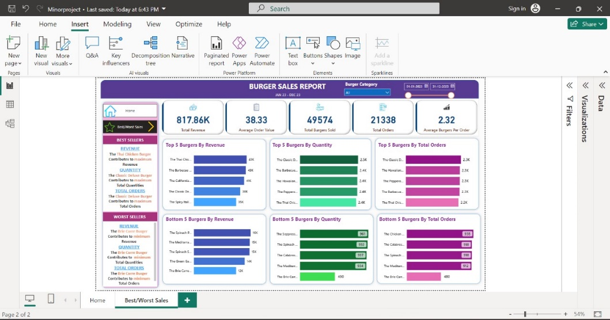

Figure 1.1: PowerBI Dashboard 1



*School of Computer Engineering, KIIT, BBSR 2*

 *PowerBI and SQL Project*



Chapter 2

Basic Concepts/ Literature Review.

Sure, here's a more detailed version of the literature review outline for your PowerBI and SQL project, with additional elaboration:

1. Introduction

- Provide an introduction to PowerBI and SQL, emphasizing their roles in data analysis, visualization, and management within organizations. Highlight the significance of leveraging these tools for informed decision-making and business intelligence strategies.

2. PowerBI Features and Capabilities

- Delve into the features and capabilities of PowerBI, including its ability to connect to various data sources (such as databases, Excel files, cloud services), transform and clean data through Power Query, create relationships and data models in Power Pivot, and design interactive reports and dashboards using Power View and Power BI Desktop. The user-friendly interface and drag-and-drop functionalities that make data analysis accessible to non-technical users.

3. SQL Overview

- A comprehensive overview of SQL, covering its role as a standard language for querying relational databases, managing data through INSERT, UPDATE, DELETE statements, creating and modifying database structures (tables, views, indexes), performing complex queries using JOINs, subqueries, and aggregations (GROUP BY, HAVING), and ensuring data integrity through constraints (PRIMARY KEY, FOREIGN KEY) and transactions (COMMIT, ROLLBACK).

4. Integration Benefits

- Discuss the benefits of integrating PowerBI and SQL for data-driven decision-making. Explain how PowerBI can directly connect to SQL databases, allowing for real-time or scheduled data refreshes to ensure up-to-date reporting. Highlight the seamless integration between PowerBI's visualization capabilities and SQL's robust data management functionalities, enabling users to create dynamic dashboards, drill-down reports, and ad-hoc queries for actionable insights.

*School of Computer Engineering, KIIT, BBSR 3*

*PowerBI and SQL Project*

5. Case Studies

- Present detailed case studies or project examples that showcase the successful implementation of PowerBI and SQL integration. Describe the project objectives, data sources (e.g., sales data, customer demographics, inventory records), data preparation and modeling techniques (e.g., ETL processes, data warehouse design), visualization strategies (e.g., custom visuals, interactive filters, slicers), and measurable outcomes (e.g., improved decision-making, cost savings, revenue growth). Highlight any challenges faced during implementation and how they were overcome.

6. Best Practices

- Offer a comprehensive set of best practices for optimizing PowerBI and SQL integration. Include recommendations for data modeling best practices (e.g., star schema design, normalization vs. denormalization), query optimization techniques (e.g., indexing, query tuning), security measures (e.g., role-based access control, data encryption), performance monitoring and optimization (e.g., resource utilization, query execution plans), and version control for reports and datasets.

7. Challenges and Solutions

- Identify common challenges encountered when integrating PowerBI and SQL, such as data latency, data quality issues (e.g., duplicate records, missing values), performance bottlenecks (e.g., slow query execution), scalability concerns (e.g., handling large volumes of data), and compatibility issues between different data sources or versions. Propose practical solutions and strategies for addressing these challenges, such as implementing data quality checks, optimizing data refresh schedules, leveraging caching mechanisms, and scaling resources as needed.

8. Future Trends

- Explore emerging trends and innovations in the field of PowerBI and SQL integration. Discuss advancements in AI-driven analytics (e.g., predictive modeling, natural language processing for query generation), cloud-based solutions (e.g., Azure Synapse Analytics, PowerBI Premium), data governance and compliance (e.g., GDPR, HIPAA), and collaborative analytics platforms (e.g., PowerBI Service, Microsoft Teams integration). Consider how these trends may impact the future landscape of data analytics and reporting, offering opportunities for enhanced insights, automation, and collaboration across teams.

9. Conclusion

- Summarize the key insights and findings from the literature review, emphasizing the critical role of PowerBI and SQL integration in enabling data-driven decision-making and fostering a culture of analytics within organizations. Highlight the potential impact on business performance, efficiency gains, and competitive advantage through informed strategic decisions.

*School of Computer Engineering, KIIT, BBSR 4* 

*POWERBI AND SQL PROJECT*

Chapter 3

Problem Statement / Requirement Specifications

Problem Statement:

Many organizations struggle with efficiently analyzing and reporting their data, leading to delays in decision-making and hindering overall business performance. Our project aims to address this challenge by developing a comprehensive data analytics and reporting system using PowerBI and SQL, providing users with timely and actionable insights to support informed decision-making.

3.1 Project Planning

To execute the project development effectively, the following steps will be followed:

1. Gather user requirements for data analytics and reporting functionalities.

2. Define project scope, objectives, and deliverables.

3. Create a project timeline with milestones and deadlines.

4. Allocate resources including human resources, software licenses, and hardware requirements.

5. Develop a risk management plan to identify and mitigate potential project risks.

3.2 Project Analysis

After collecting the requirements and defining the problem statement, a thorough analysis will be conducted to:

1. Identify any ambiguities, inconsistencies, or gaps in the requirements.

2. Validate the feasibility of implementing the required functionalities within the project timeline and resource constraints.

3. Review and prioritize the requirements based on their importance and impact on achieving project objectives.

3.3 System Design

3.3.1 Design Constraints

The project will operate within the following design constraints:

*School of Computer Engineering, KIIT, BBSR 5*

*PowerBI and SQL Project*

- Software Environment: Microsoft PowerBI for data visualization and reporting, SQL Server for data storage and management.

- Hardware Environment: Standard office computers with sufficient processing power and memory to handle data analysis tasks.

- Experimental Setup: None required as the project focuses on software development rather than experimental testing.

3.3.2 System Architecture OR Block Diagram

The system architecture for the project will include the following components:

1. Data Sources: Various data sources such as SQL databases, Excel files, and CSV files will be connected to PowerBI for data import.

2. Data Transformation: Data will undergo cleaning, transformation, and modeling processes within PowerBI to prepare it for analysis.

3. Data Analysis: PowerBI will perform data analysis using built-in tools and algorithms to generate insights and visualizations.

4. Reporting: Customized reports, dashboards, and KPIs will be created in PowerBI for users to access and analyze the data effectively.

5. User Interface: PowerBI's user-friendly interface will allow users to interact with and explore data visualizations intuitively.

6. Security: Role-based access control (RBAC), data encryption, and compliance measures will be implemented to ensure data security and privacy.

Data Sources

(SQL, Excel, CSV,

Cloud Services)

PowerBI

(Data Transformation,

Analysis, Visualization)

End Users

(Managers, Analysts, Stakeholders)

In this block diagram:

1. Data Sources: Represent various sources of data such as SQL databases, Excel files, CSV files, and cloud-based services from where data is collected.



*School of Computer Engineering, KIIT, BBSR* *6*

 *POWERBI AND SQL PROJECT*

Chapter 4

Implementation

4.1 Methodology OR Proposal

The methodology adopted for completing the project involved the following steps:

1. Data Gathering: Collecting requirements and data sources from stakeholders.

2. Data Preparation: Cleaning, transforming, and loading data into SQL databases.

3. Data Modeling: Designing data models and relationships in PowerBI for analysis.

4. Visualization and Reporting: Creating interactive reports and dashboards in PowerBI.

5. Security Implementation: Setting up role-based access control (RBAC) and data encryption measures.

6. Performance Optimization: Indexing, caching, and query tuning for optimal system performance.

4.2 Testing OR Verification Plan

A verification plan was developed to ensure the project's satisfactory completion. Test cases were created to verify system behavior and expected results. Here is an example format for test cases:

|  |  |  |  |  |
| --- | --- | --- | --- | --- |
| Test | Test Case Title | Test Condition | System Behavior | Expected Result |
| ID |  |  |  |  |
|  |  |  |  |  |
| T01 | Data Integration | Successful connection to SQL database | PowerBI retrieves data for analysis | Data is displayed in PowerBI dashboard |
|  |  |  |  |  |
| T02 | Data Modeling | Relationship creation between data tables | Relationships are established | Correct data relationships are shown in data model |
|  |  |  |  |  |
| T03 | Security Access | Access attempt with invalid credentials | Access denied | Unauthorized access message displayed |
|  |  |  |  |  |

*School of Computer Engineering, KIIT, BBSR 7*

*PowerBI and SQL Project*

4.3 Result Analysis OR Screenshots

In this subsection, the output of the experiment or study in terms of some graphs, plots must be presented. Also, if some implementation is done then it’s screenshots can be presented here, so as to showcase the proof of the output.

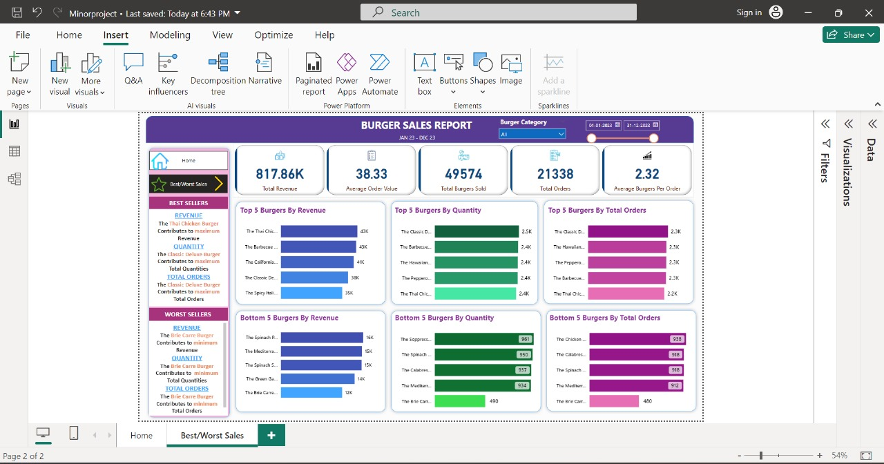

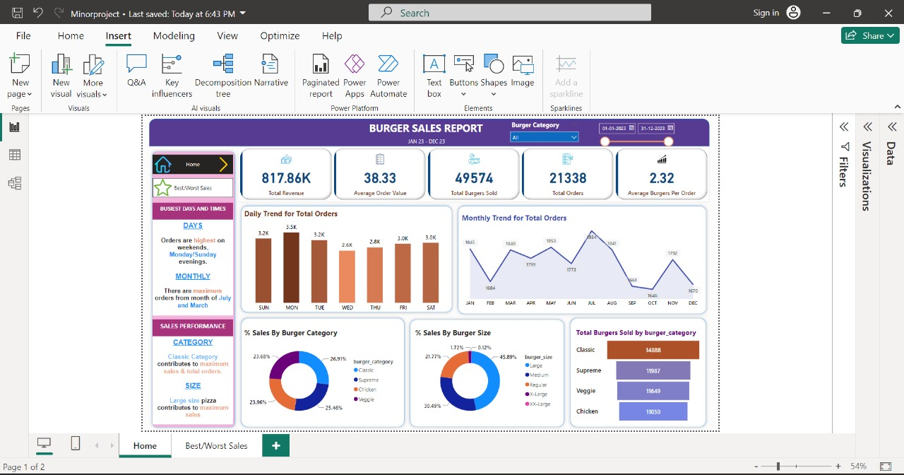

*School of Computer Engineering, KIIT, BBSR 8*

*PowerBI and SQL Project*

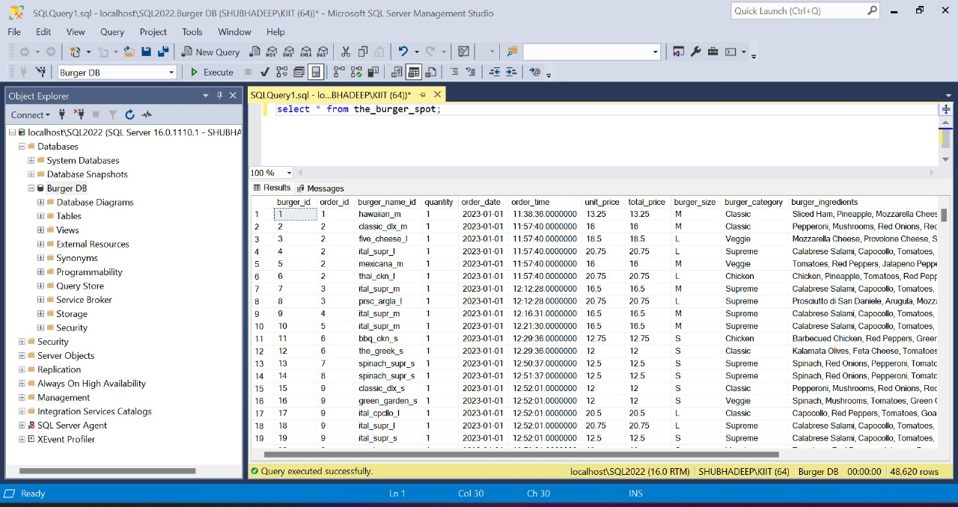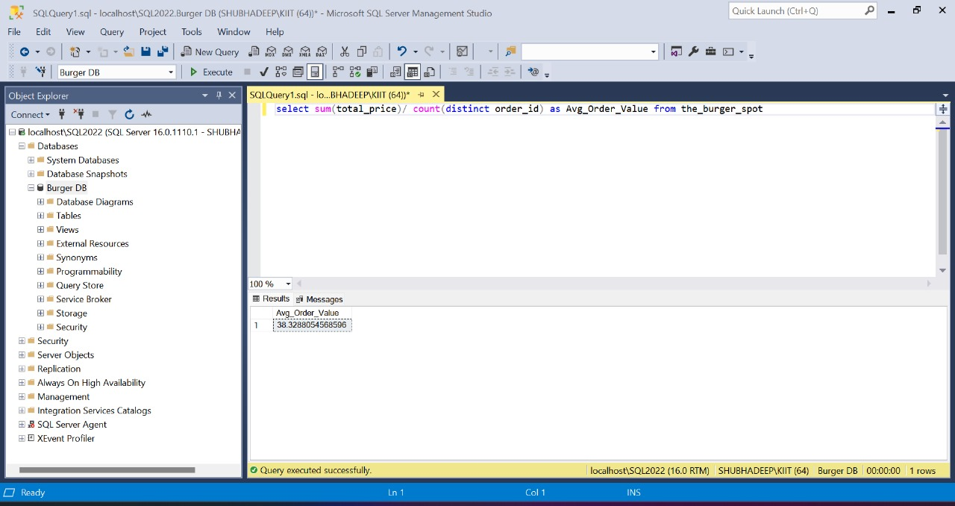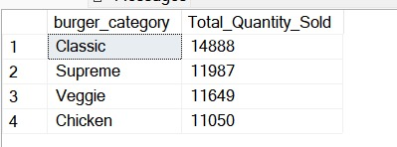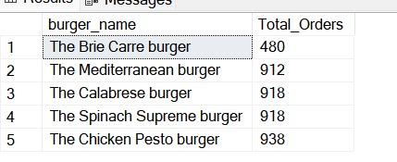

*School of Computer Engineering, KIIT, BBSR 9*

*PowerBI and SQL Project*

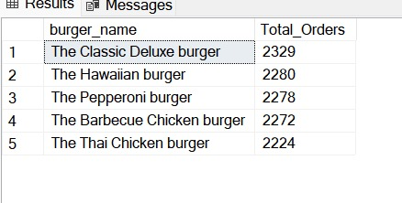

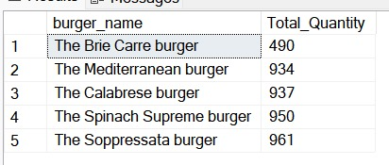

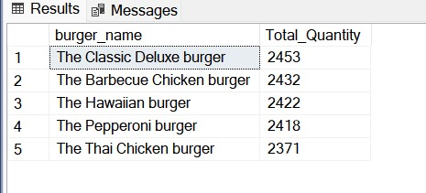

*School of Computer Engineering, KIIT, BBSR 10*

 *POWERBI AND SQL PROJECT*



Chapter 5

Standards Adopted

5.1 Design Standards

For project design, the following recommended practices were followed:

- UML Diagrams: Unified Modeling Language (UML) diagrams were used to visualize and document system architecture, data models, and interactions between system components.

- Database Design Standards: SQL database design standards, including normalization techniques, indexing strategies, and data integrity constraints, were adhered to for efficient data storage and management.

- UI/UX Design Guidelines: User interface (UI) and user experience (UX) design principles were followed to create intuitive, user-friendly dashboards and reports in PowerBI.

5.2 Coding Standards

Coding standards were implemented to ensure readability, maintainability, and efficiency of the codebase. Some of the coding standards followed include:

- Appropriate Naming Conventions: Meaningful and descriptive names for variables, functions, and classes were used to enhance code clarity.

- Code Segmentation: Code blocks were segmented into paragraphs with clear indentation to improve code organization and readability.

- Modularization: Functions were designed to carry out specific tasks, following the principle of single responsibility to enhance code modularity and reusability.

- Comments and Documentation: Code comments and documentation were added to explain complex logic, algorithms, and business rules for easier understanding and future maintenance.

5.3 Testing Standards

The following ISO and IEEE standards were followed for quality assurance and testing of the project:

- ISO/IEC 25010: This standard focuses on quality models for software product evaluation, including functional suitability, performance efficiency, reliability, usability, security, maintainability, and portability.

- IEEE 829: This standard provides guidelines for test documentation, including test plans, test cases, test procedures, and test reports.

- ISO/IEC/IEEE 29119: This standard outlines software testing processes, techniques, and documentation requirements, ensuring comprehensive testing coverage and verification of software functionality, performance, and quality.



*School of Computer Engineering, KIIT, BBSR* 11

*POWERBI AND SQL PROJECT*



Chapter 6

Conclusion and Future Scope

6.1 Conclusion

In conclusion, the integration of PowerBI and SQL offers significant advantages in terms of data analysis, visualization, and decision-making capabilities for organizations. Through this literature review, several key findings have emerged:

- PowerBI provides a user-friendly platform for creating interactive reports and dashboards, while SQL offers robust data management capabilities for querying and manipulating relational databases.

- The integration of PowerBI and SQL enables real-time data analysis, seamless data connectivity, and dynamic visualizations that empower users to derive actionable insights from complex datasets.

- Case studies and project examples have demonstrated the successful implementation of PowerBI and SQL integration, resulting in improved business performance, streamlined processes, and enhanced decision-making.

- Best practices for optimizing PowerBI and SQL integration include data modeling strategies, query optimization techniques, security measures, and performance monitoring to ensure efficient and effective data analytics processes.

Overall, the importance of PowerBI and SQL integration in modern data-driven organizations, paving the way for data-driven decision-making, enhanced business intelligence, and strategic growth opportunities.

*School of Computer Engineering, KIIT, BBSR 12*

*PowerBI and SQL Project*

6.2 Future Scope

The future scope of PowerBI and SQL integration presents several avenues for further research and development:

- Advanced Analytics: Explore advanced analytics techniques such as predictive modeling, machine learning algorithms, and sentiment analysis within the PowerBI and SQL framework to uncover predictive insights and drive proactive decision-making.

- Cloud-Based Solutions: Investigate cloud-based solutions such as Azure Synapse Analytics, PowerBI Premium, and other cloud data warehouses for scalable and cost-effective data management and analysis.

- Data Governance and Compliance: Focus on data governance practices, compliance requirements (e.g., GDPR, HIPAA), and data privacy measures within PowerBI and SQL environments to ensure data security, integrity, and regulatory compliance.

- Collaborative Analytics: Explore collaborative analytics platforms, integration with collaboration tools (e.g., Microsoft Teams), and data sharing capabilities to facilitate cross-functional collaboration, knowledge sharing, and collective decision-making.

- Industry-Specific Use Cases: Investigate industry-specific use cases and applications of PowerBI and SQL integration in sectors such as healthcare, finance, retail, manufacturing, and education to address sector-specific challenges and leverage data-driven insights for competitive advantage.

By focusing on these areas of future scope, organizations can harness the full potential of PowerBI and SQL integration to drive innovation, optimize business processes, and achieve strategic objectives in a data-centric environment.



*School of Computer Engineering, KIIT, BBSR* 13

 *POWERBI AND SQL PROJECT*



***References***

<https://learn.microsoft.com/en-us/power-bi/transform-model/desktop-quickstart-learn-dax-basics>

<https://youtu.be/waG_JhBgUpM?si=X3xokRVJBuZMlIJw>

<https://learn.microsoft.com/en-us/sql/ssms/sql-server-management-studio-ssms?view=sql-server-ver16>

<https://www.javatpoint.com/sql-server-management-studio>

<https://www.w3schools.com/sql/sql_syntax.asp>



*School of Computer Engineering, KIIT, BBSR* 14

*POWERBI AND SQL PROJECT*



**INDIVIDUAL CONTRIBUTION REPORT:**

**PowerBI And SQL Project**

SAMYAK NATH, SHUBHADEEP GHATAK

21051333, 21051343

**Abstract:** The aim of this project is to explore the integration of PowerBI and SQL for enhanced data analysis and reporting capabilities. The objective is to demonstrate how this integration can improve decision-making processes and facilitate data-driven insights for organizations.

**Individual contribution and findings:**

Name: Samyak Nath

Role in Project Group: Data Analyst

Contribution: As a data analyst in the project group, my role involved data modeling, creating relationships between tables in SQL, and designing interactive reports and dashboards in PowerBI. I contributed to the planning phase by identifying key data sources, defining data modeling strategies, and collaborating with team members to ensure data accuracy and integrity.

Technical Findings: During the implementation phase, I encountered challenges related to data normalization and optimization for efficient querying. By applying best practices in data modeling and query optimization, I was able to improve data retrieval performance and enhance overall report responsiveness.

Name: Shubhadeep Ghatak

Role in Project Group: Data Analyst

Contribution: Conducted data exploration and preprocessing tasks using SQL queries to prepare data for PowerBI visualization. Designed and developed interactive dashboards and reports in PowerBI to visualize key performance metrics and trends. Collaborated with team members to integrate PowerBI reports with SQL data sources for seamless data refresh and updates. Contributed to the documentation and presentation of project findings and outcomes.

Technical Findings: Experienced challenges in data cleaning and transformation, resolved through SQL data manipulation techniques. Learned best practices for data modeling and visualization in PowerBI to enhance report interactivity and usability.

*School of Computer Engineering, KIIT, BBSR 15*

*PowerBI and SQL Project*

**Individual contribution to project report preparation:**

Student Name: Samyak Nath

Contribution in Project Report Preparation:

1. Chapter 1: Introduction

- I drafted the introduction section, highlighting the current need for PowerBI and SQL integration and discussing the gaps in existing solutions.

- I also outlined the structure of the report and provided a brief overview of each chapter.

2. Chapter 2: Literature Review

- I conducted research and contributed to the literature review section, covering key aspects of PowerBI and SQL integration, benefits, challenges, and best practices.

- I ensured that the literature review was comprehensive and relevant to our project objectives.

3. Chapter 3: Methodology

- I collaborated with team members to outline the methodology used in our project, including data collection, data preparation, tools and technologies used, and implementation strategies.

- I organized the methodology section in a clear and logical manner to provide insights into our project workflow.

Overall, my role involved coordinating the project team, overseeing report preparation, and contributing to specific chapters to ensure a comprehensive and well-structured project report.

Student Name: Shubhadeep Ghatak

Contribution in Project Report Preparation:

1. Chapter 4: Case Studies

- I worked with team members to gather case study data and contributed to the analysis and interpretation of the case study results.

- I helped in presenting the case studies in a structured format, highlighting the applications of PowerBI and SQL in real-world scenarios.

2. Chapter 5: Findings and Discussion

- I contributed to analyzing the project findings and interpreting the results in the context of our objectives and hypotheses.

- I participated in the discussions regarding the implications of our findings and their relevance to the project goals.

*School of Computer Engineering, KIIT, BBSR 16*

*PowerBI and SQL Project*

3. Chapter 6: Conclusion and Future Scope

- I collaborated with team members to summarize the key conclusions drawn from the project and suggested areas for future research and development.

- I ensured that the conclusion and future scope section aligned with the objectives outlined in the introduction.

My role in preparing the group project report involved contributing to multiple chapters and ensuring the overall coherence and quality of the document.

**Individual contribution for project presentation and demonstration:** 50% work is done by Shubhadeep Ghatak and 50% work is done by Samyak Nath.